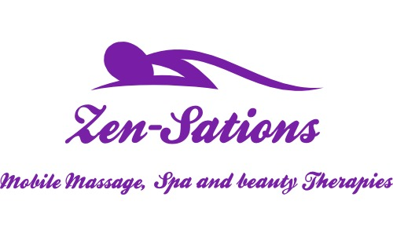
Massage Aftercare Advice
After the treatment you may experience various reactions, none of which you should be concerned with. The body has been stimulated and relaxed and it is now adjusting to this by ridding itself of toxins and working on any problem areas that have been treated.

Soon after treatment you should:
z. Relax for a while.
z. Wrap up warmly. You might feel cold after a treatment.
z. Take care when driving home as your reflexes might be slower. You may feel faint or
tired.

To get the best results of your massage you should:
z. Drink plenty of water. Your body might have been drained of lymphatic waste and
toxins, which may result in being thirsty. The water will help to flush all the waste and
toxins away. Water will also help the detoxifying process and rehydration of your body.
z. Have a bath to continue the relaxation process or listen to soft relaxing music
z. Have a nap or rest if you can – it will make the muscles relax and make the massage
last longer.
z. Pay attention to general posture. Sitting and walking up straight is of importance.

For 12 hours following your massage, you should avoid:
z. Consuming a heavy meal. Your body is in a healing state and is thus resting; massage stimulates the digestive system and therefore might make you feel nauseous.
z. Drinking a lot of caffeine drinks (tea, coffee, red bull) or stimulants
z. Drinking alcohol as it might cause dehydration.
z. Using a sauna, steam room or sun bed.

Following your massage treatment you may experience over the next few days some of the following contraindications:
z. Heightened emotions–high or low
z. Feeling sleepy & fatigued or deeply relaxed
z. Temporary worsening of symptoms of current ailments.
z. Increased thirst.
z. Increased urination.
z. Erythema (reddening of skin due to increased blood supply): Increased blood supply
promotes healing and flushes muscles of lactic acid and other toxins.

Book regular massages, as advised by your therapist to maintain the effects.

